**Mini-Project Summary**:

Steps:

1. Analyze each file:
   1. Conclusions:
   2. Each file has a header of 14 rows with various values followed by time values which are then followed by sensor readings

Example reading vs. time:

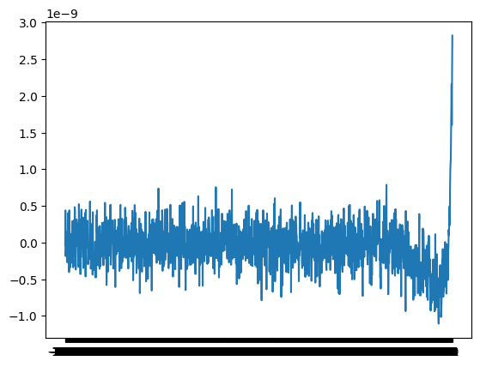

* 1. Transpose was needed to convert into a multiple rows indicating different times. Why is this important? Thinking ahead, to combine different txt files for single volcano, need to concatenate

1. For use with “tsfresh”, we also need to add the fileid in the first column
2. The initial feature extraction along with data, only had cases with eruption, so the train data and test data matched completely. How to we get data where there is no eruption?

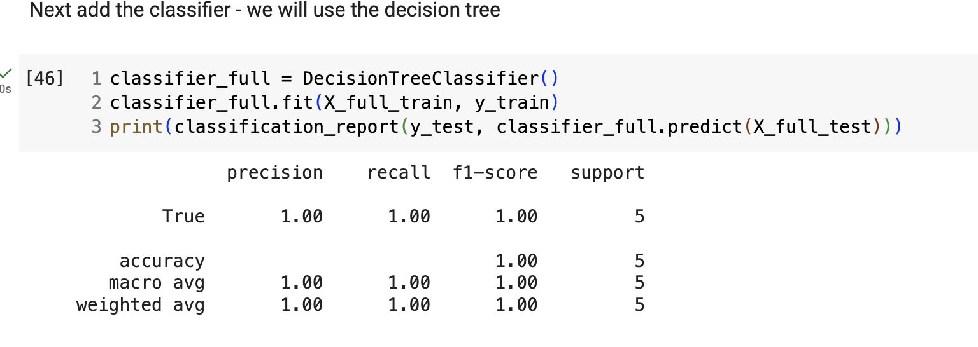

1. After updating with training test size of 0.8, a good predictor is obtained

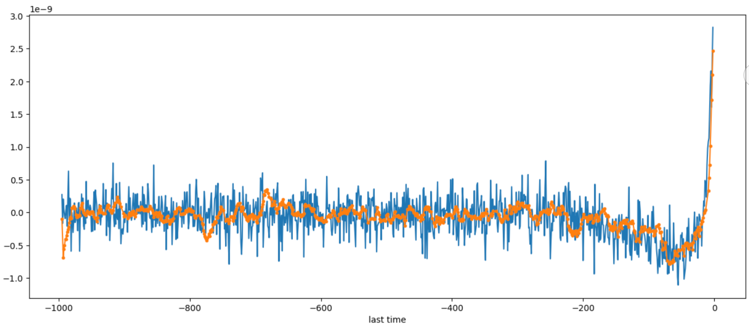

However notice that the test is only 20% of data. Additionally, the points taken are random, and hence the measurement is fair.

1. Now given a test data at the initial stage, lets see how the activity can be predicted.